CATHOLIC EDUCATION WEEK – THOSE WHO HOPE IN THE LORD
SHALL RENEW THEIR STRENGTH

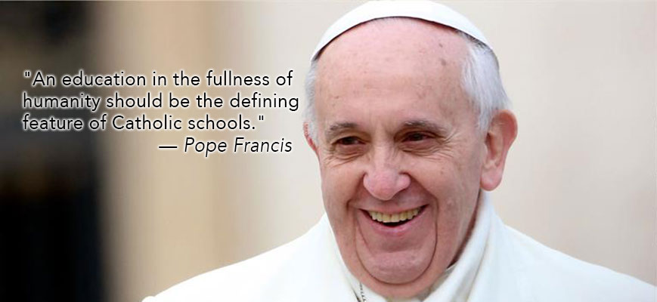Friends of Jesus,
Every year, on the Feast of the Ascension of Our Lord (40 days after Easter), Catholics across the globe give thanks for the gift of Catholic Education through the celebration of the World Catholic Education Day. This year, the theme of Catholic Education Week in the province of Alberta is Those Who Hope in the Lord Shall Renew Their Strength. The theme for this year’s Catholic Education Week is taken from the book of Isaiah 40:31. It offers us the prophet’s words of hope and prophetic fulfillment in the face of challenges that we have experienced throughout this school year. “Today too, amid so much darkness, we need to see the light of hope and to be men and women who bring hope to others. To protect creation, to protect every man and every woman, to look upon them with tenderness and love, is to open up a horizon of hope; it is to let a shaft of light break through the heavy clouds; it is to bring the warmth of hope!” – Pope Francis’ Homily for Inaugural Mass of Petrine Ministry, March 19, 2013.
How wonderful it is to celebrate Catholic Education Week in the month of May that in the Catholic Liturgical Calendar is dedicated, in a special way, to Mary! Mary, the Mother of God, is also the patron saint of our Edmonton Catholic Schools.
Today, I invite you to reflect and learn more about Mary, who was the first evangelizer and the first disciple of her own Son, Saviour, and Lord, Jesus Christ. Mary gave the first Gospel testimony to her cousin, Elizabeth, without words. She understood the work of the Holy Spirit unlike anyone else in the history, other than her beloved Son, Jesus Christ. There are very few records of Mary’s obvious words in the texts of the New Testament. However, there is no lack of her presence at the most important events in the life, ministry, death, and resurrection of her Son. Mary always encountered God in profound ways from the beginning to the end of her earthy life. In every encounter, she surrendered to love and was changed.
From antiquity, Mary has been called the Mother of God – Theotokos – the Greek word that means God-Bearer. The word Theotokos is used throughout the Eastern Catholic Church’s Liturgy. It is also at the heart of the Latin Rite’s deep Marian piety and devotion. An insistence of the Early Church Council on the use of the title, Theotokos – the Mother of God, reflected an effort to preserve the teaching of the Church that Jesus Christ is both divine and human and that these two natures are always united in His One Person (The Third Ecumenical Council of Ephesus, 431 A.D.).
On May 13, in honour of World Catholic Education Day, we are encouraged to wear blue, and that way be united in faith and prayer for Catholic Education. As Mary, the Mother of God, is traditionally portrayed in blue in many of the paintings and icons, we stand united in prayer with her and grateful for the Catholic Schools as we offer our prayer to God. As we celebrate Catholic Education Week, from May 10th to 14th this year, I invite you to join all the faithful in praying for Catholic Education, the students whom we serve, their parents and families, and our trustees, administrators, teachers, and staff who make it all possible.
Fr. Julian Bilyj
ECSD Chaplain

