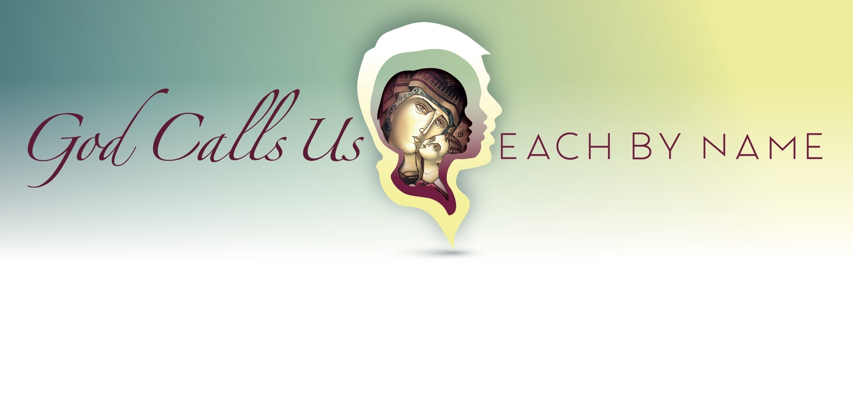

February 2021

“Lent is a time of going very deeply into ourselves… What is it that stands between us and God? Between us and our brothers and sisters? Between us and life, the life of the Spirit? Whatever it is, let us relentlessly tear it out, without a moment’s hesitation.”
- Servant of God Catherine Doherty

This month marks the beginning of Lent in the Catholic liturgical calendar. It is a journey where we prepare our hearts and our minds to receive the great gift of God’s mercy and love that is found in the death and resurrection of Christ. As the quotation above points out to us, it is a time for us to truly discern those parts of our lives that cut us off from the vital relationships with God and each other. In today’s world where we are necessarily placed at a physical distance from others, removing spiritual, social, and emotional barriers takes a position of even greater importance in our lives.

February is always an incredibly busy month for schools. Our high schools will experience quarter change on February 1. Our Grade 8 students will be engaged in a morning of social justice learning on February 11 as they participate in our annual Father Michael ‘Catfish’ Mireau Youth Faith Day as a virtual event. The theme for the day, Serve Like A Superhero, reminds them that they can make a difference in the world. Random Acts of Kindness Week will see our students and staff reaching out to others in small ways to brighten their day. Our schools will be participating in Ash Wednesday according to the guidelines set forth by the Archdiocese. Ashes will be sprinkled ensuring that they are distributed without contact. Our Division Chaplains, Father Glenn McDonald and Father Julian Bilyj, will offer a recorded celebration so that our remote learners can also participate in this important day. As always, Teachers’ Convention will take place on the last Thursday and Friday of February. Our teachers will engage in valuable professional learning in a virtual environment.

Our virtual mental health evening for parents and guardians in January was a great success. We had over 500 participants on the day of the event, and the recording is available for you on our website. Click here to view this very valuable 45-minute video.
Our online registration is now open, and if you are looking at registering with Edmonton Catholic Schools, you can find all of the virtual Open House listings by exploring www.ecsd.net or by clicking here. Share the good news about us in your community!
Pope Francis published an encyclical letter, Fratelli Tutti: On Fraternity and Social Friendship, last fall. This month, our Religious Education Services (RES) Elementary Consultant writes about chapter 3, Envisaging and Engendering an Open World, and chapter 4, A Heart Open to the Whole World. The article is included as an accompaniment to this newsletter.

In this month in which we are focused on relationship, kindness, and serving others, I will leave you with a final word from our Holy Father: “The design that God has for each one of us is always a design of love. And the greatest joy for every believer is to respond to that call, offering one’s entire being to the service of God and the brothers and sisters.” (Twitter, 01-17-21)

Have a grace filled month!

Sincerely,
Robert Martin
Chief Superintendent

